**BEHAVIOURAL DIAGRAM:**

1. **User Case Diagram:**

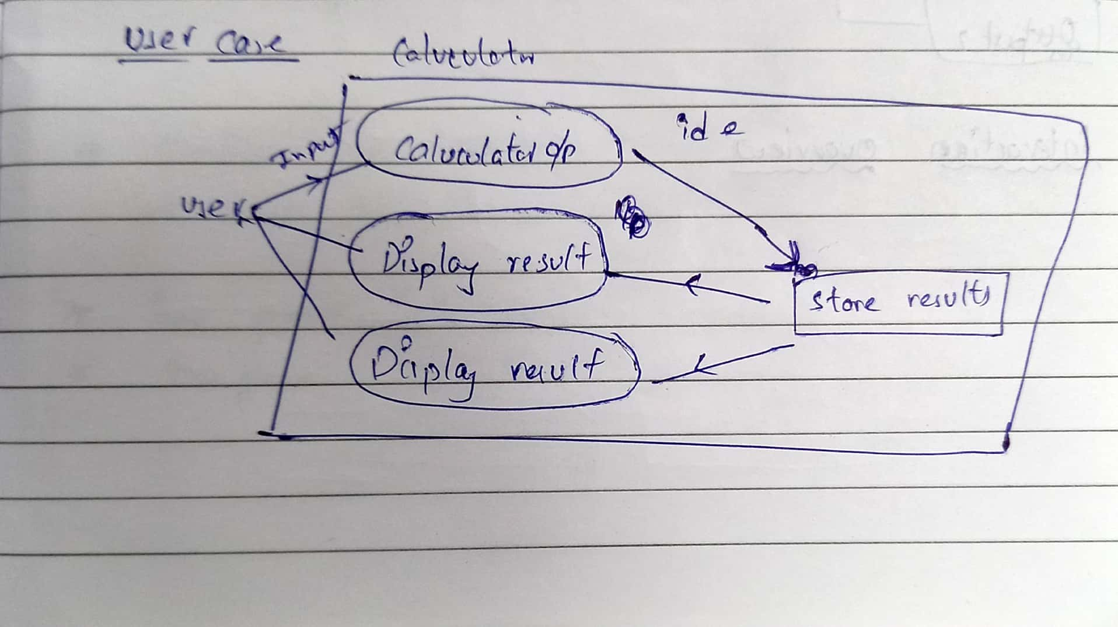

1. **Activity Diagram:**

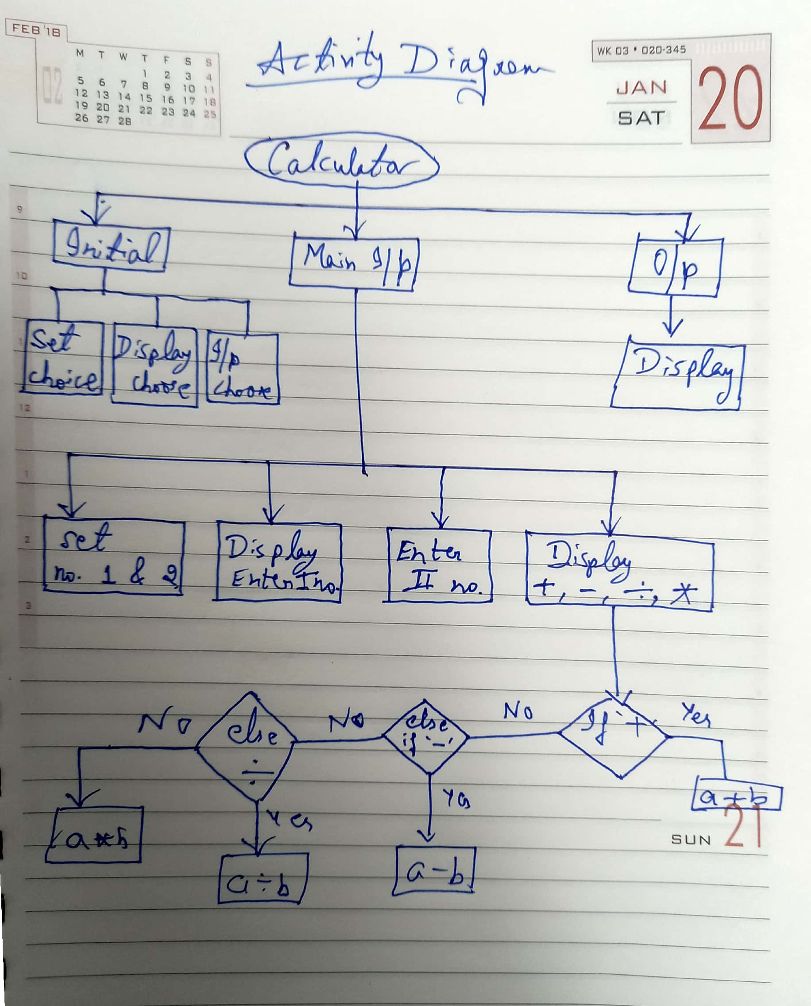

1. **State Machine Diagram:**

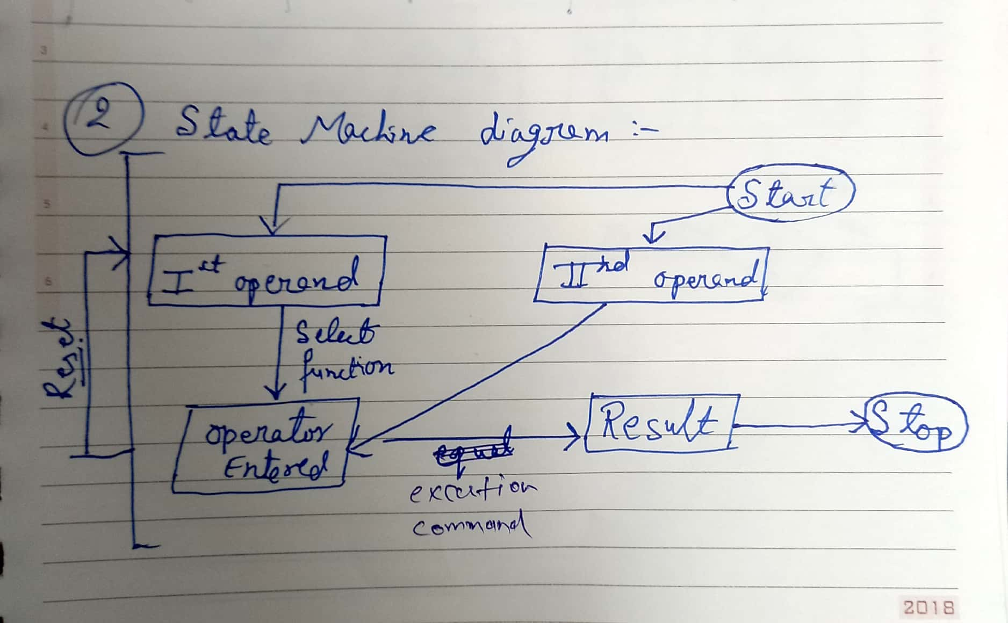

1. **Sequence Diagram:**

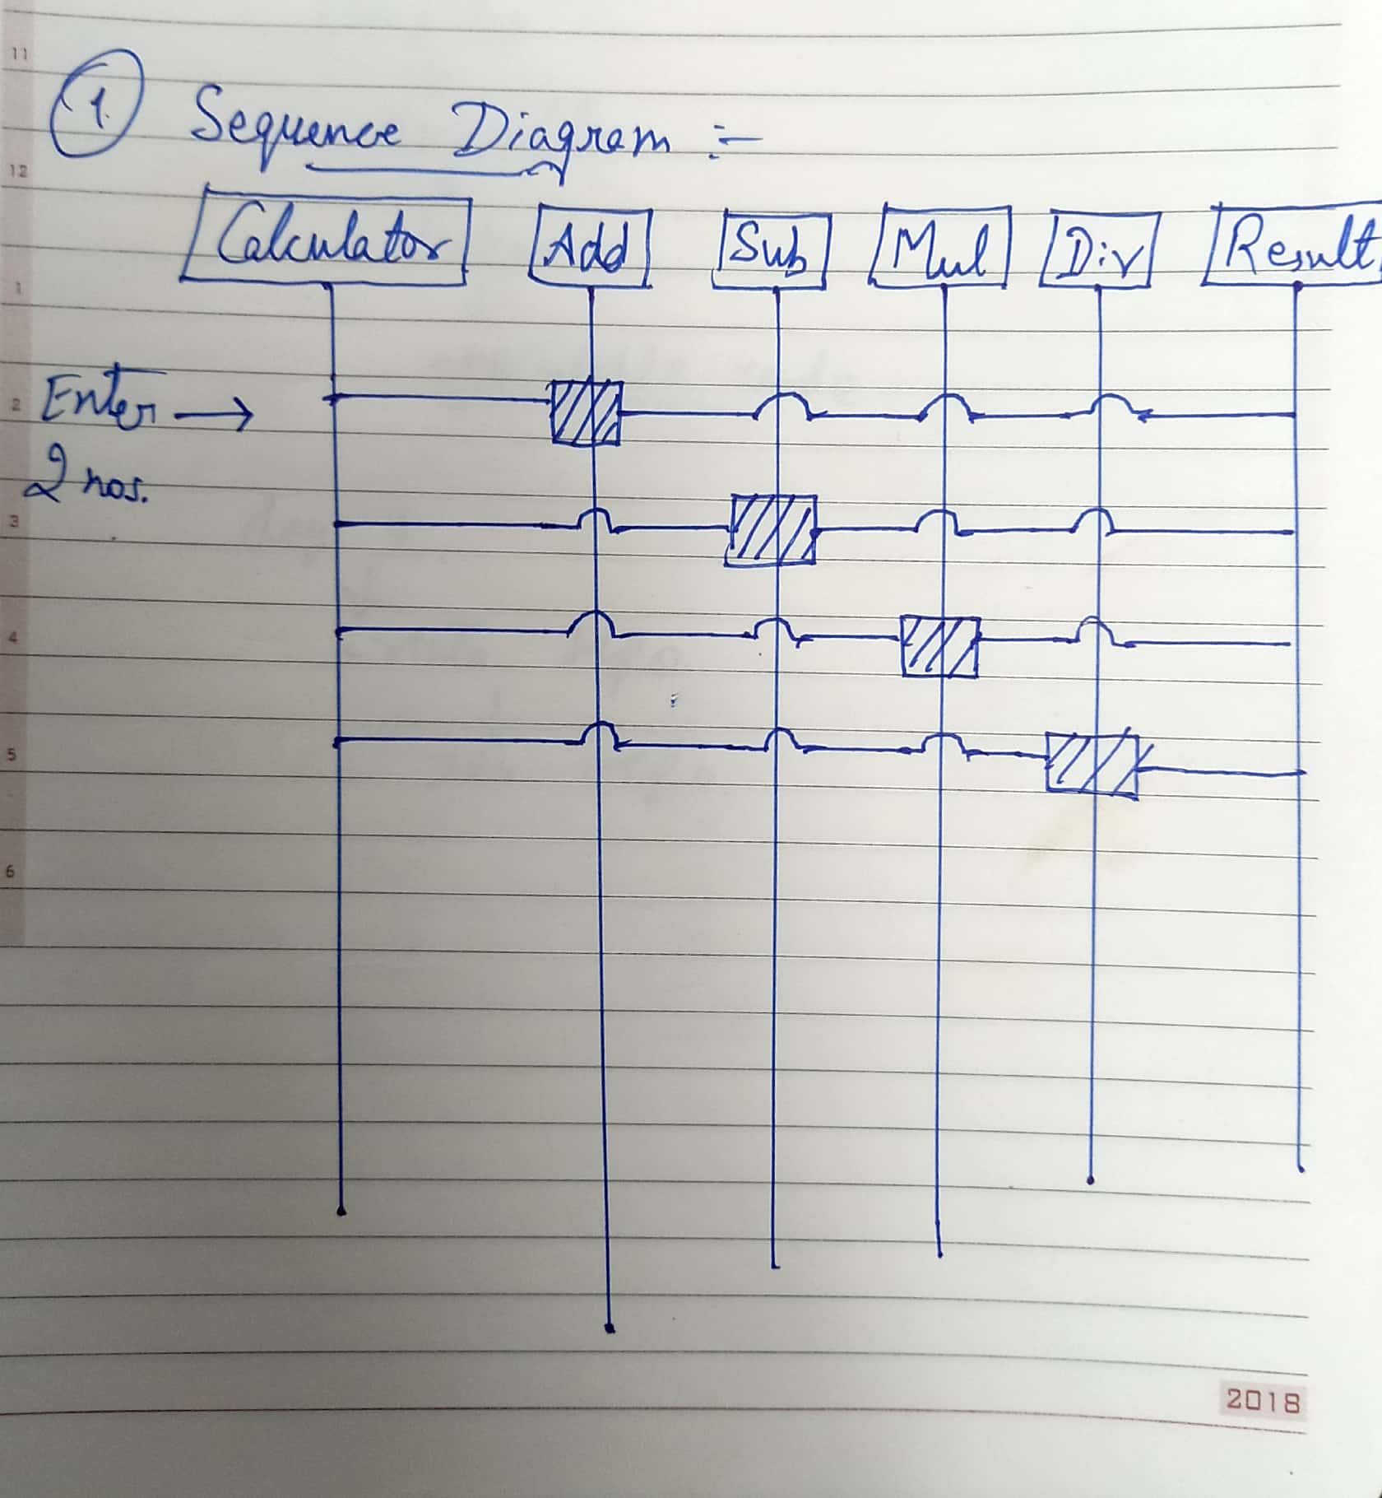

1. **Interaction overview:**

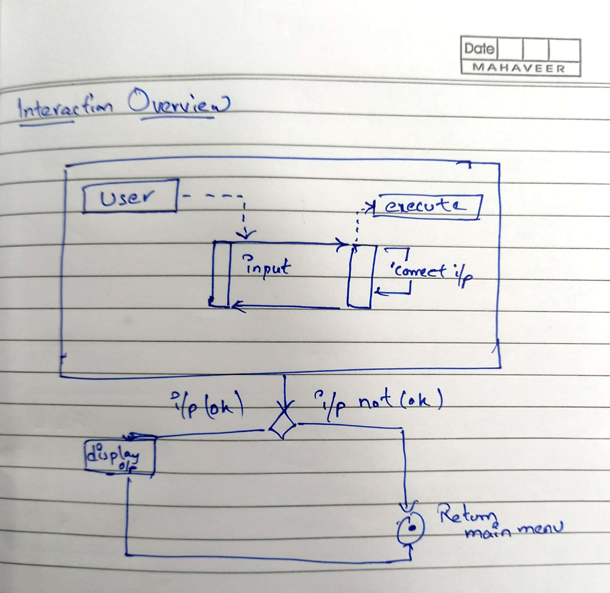

1. **Timing Sequence:**

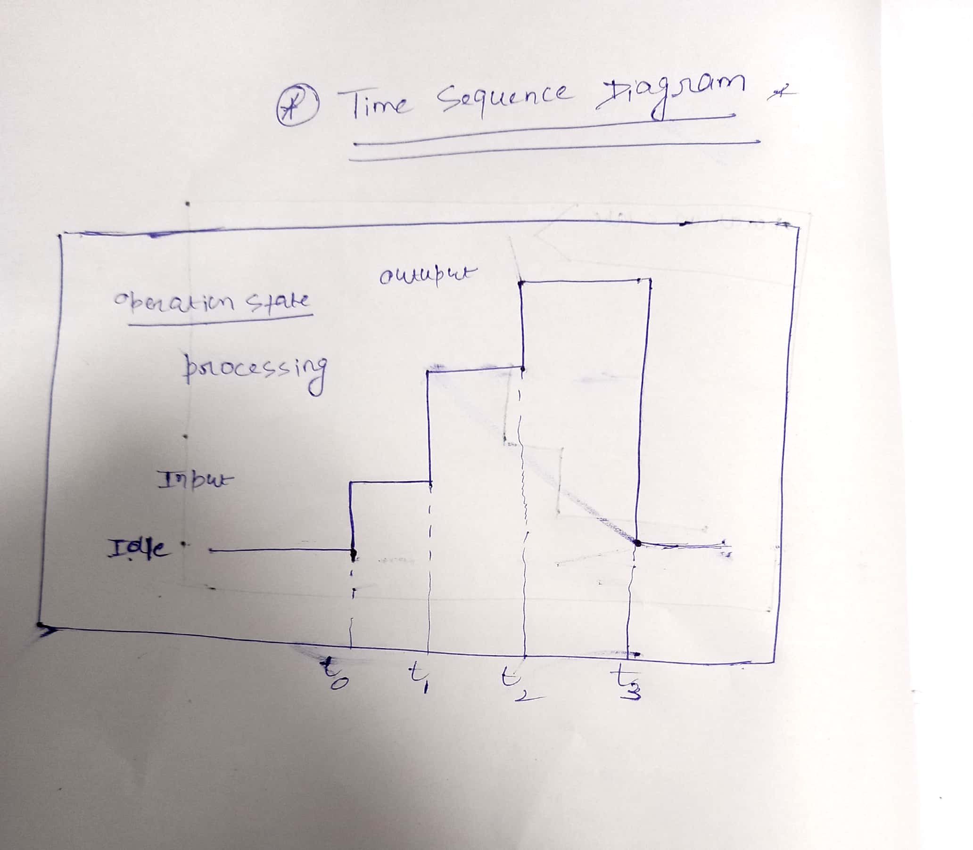

1. **Communication Diagram:**

